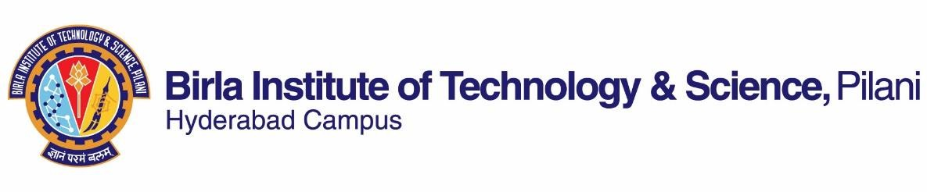

# SECOND SEMESTER 2023-2024

Course Handout Part II

Date: 09/01/2024

In addition to part-I (General Handout for all courses appended to the timetable) this portion gives further specific details regarding the course.

*Course No. :* CHE F411

*Course Title :* Environmental Pollution Control

*Instructor-in-Charge :* Prof Jaideep Chatterjee

**Course Description:**

This course has been designed with the view that Environmental degeneration due to anthropogenic activities, is a major cause for concern and hence is a critical area of expertise whose significance will continue to grow in the future. The first part of the course covers various aspects of air-pollution, such as dispersion of air pollutants, Indoor air-pollution and technologies to mitigate air-pollution. The second part of the course deals with water pollution, which include basic understanding of various causes and emerging issues in the area of water pollution. The course then covers many conventional and emerging technologies used to treat waste-water. The course also covers solid waste and hazardous waste management. The topic of Noise pollution and its mitigation will also be covered.

**Scope and Objective**

* Understanding of air pollution from stationary and mobile sources
* Know-how of state-of-art technologies available for preventing and mitigating air-pollution.
* Understanding the importance of atmospheric dispersion in air-pollution
* Understanding of Water pollution from municipal and industrial sources
* Know-how of state-of-art and emerging technologies available for treating waste-water.
* Know-how of solid waste management techniques
* Understanding of Noise pollution, its quantification and mitigation.

**Textbook:**

1. Mackenzie L Davis, David A Cornwell. Introduction to Environmental Engineering, Fourth Edition. McGraw Hill, 2010.
2. Rao, C.S., Environmental Pollution Control Engineering, New Age International 2nd Ed., 2006.

**Reference books Course Plan:**

|  |  |  |  |
| --- | --- | --- | --- |
| **Lecture No.** | **Learning objectives** | **Topics to be covered** | **Chapter in the Text Book** |
| 1 | Air Pollution: Sources and Effects | Types of air pollutants, Effect of air pollution, Air pollution laws and standards | TB1 Chapter 9  TB2 Chapter 2 |
| 2-3 | Meteorological Aspects of Air Pollutant Dispersion | Concept of dispersion of pollutants in atmosphere, Understanding of air dispersion models | TB1 Chapter 9  TB2 Chapter 3 |
| 4-5 | Indoor Air Pollution | Indoor air-purification. Air-purification wrt  micro-organisms & viruses | TB1 Chapter 9 |
| 6-10 | Air Pollution Control Methods & Equipment  (Control of Particulate Pollutants) | Gravity Settlers, Cyclone separators, Electrostatic precipitation, Air Filtration, wet- scrubbers | TB1 Chapter 9  TB2 Chapter 5 |
| 10-16 | Air Pollution Control Methods & Equipment  (Control of Molecular  Pollutants) | Spray towers, Packed towers, Venturi- scrubbers, Adsorption, Absorption, Incineration, Catalytic Oxidation | TB1 Chapter 9  TB2 Chapter 5 |
| 17-19 | Control of Specific Gaseous Pollutants | Various control techniques for pollutants such  as SO2, NOX, CO and hydrocarbons | TB1 Chapter 9  TB2 Chapter 6 |
| 20 | Control of pollution from Mobile sources (Vehicular) | Various control techniques for addressing vehicular pollution | TB1 Chapter 9 |
| 21 | Sampling and Measurement of air-pollutants | Sampling and Measurement techniques used in air-pollution | TB1 Chapter 9  TB2 Chapter 4 |
| 22-24 | Introduction to Water Pollution | Introduction to water pollution, Types of water pollutants, acidification of natural waters | TB1 Chapter 7  TB2 Chapter 7 |
| 25-28 | Parameters for measuring Water Pollution | Understanding of concepts of DO, BOD, COD, TOC, The DO sag curve | TB1 Chapter 7  TB2 Chapter 8 |
| 29-32 | Wastewater Treatment (Primary and Secondary ) | Primary and secondary (Bio-logical) treatment of waste-water | TB1 Chapter 8  TB2 Chapter 9 |
| 33-34 | Advanced physical treatment methods | Conventional & Advanced physical treatment techniques for water purification | TB1 Chapter 6 |
| 35-38 | Advanced Chemical treatment methods | Conventional & Advanced chemical treatment techniques for water purification | TB1 Chapter 6 |
| 39-40 | Solid Waste & Hazardous Waste Management | Classification of solid waste & Various disposal methods, Classification of Hazardous waste | TB1 Chapter 11 & 12  TB2 Chapter 10 & 11 |
| 41-42 | Noise Pollution, Its quantification & Mitigation | Understanding of noise pollution & its quantification , measurement and impact | TB1 Chapter 10 |

**Evaluation Scheme:**

|  |  |  |  |  |
| --- | --- | --- | --- | --- |
| **Component** | **Duration** | **Weightage (%)** | **Date & Time** | **Nature of Component** |
| Class Test 1 | 50 min | 10 % | Before 28/02/24 | OB |
| Mid-Semester | 90 min | 25 % | 15/03 - 11.00 - 12.30PM | OB |
| Class Test 2 | 50 min | 10 % | Before 15/04/24 | OB |
| Assignment | 1 week | 10 % | Before 30/04/24 | OB |
| Comprehensive Exam | 180 mins | 45 % | 16/05 AN | OB |

**Chamber Consultation Hour:** 5 PM – 6 PM MWFs.

**Notices:** All notices concerning this course will be uploaded in CMS

**Make-up Policy: Only with prior permission from IC**.

**Academic Honesty and Integrity Policy:** Academic honesty and integrity are to be maintained by all the students throughout the semester and no type of academic dishonesty is acceptable.

# INSTRUCTOR-IN-CHARGE

**Jaideep Chatterjee**

**CHE F411**